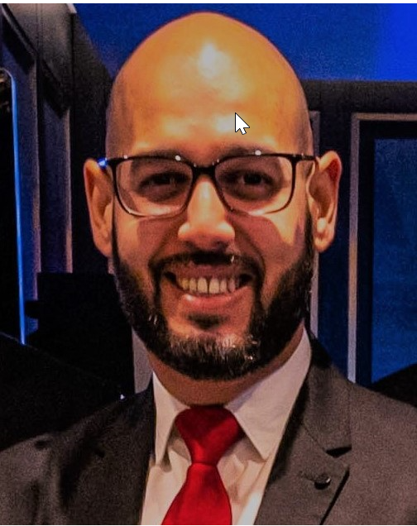 DORIN
CRISTIAN
Casino Manager

CONTACT INFO

Phone
+447575370600

Email
dorucasino@gmail.com

Experienced and effective Casino Manager adept in all aspects of successful gambling operations. Bringing forth several years of industry experience and expertise in managing staff and casino operations. Equipped with a diverse and promising skill-set, conducive to creating positive team relationships resulting in optimal customer service. Passionate about all aspects of gambling industry, and eager to bring my years of experience and growth to the company.
About
Self-Development
My experiences helped me develop good communication skills, excellent customer service and ability to work with and lead different nationalities. Over the years I also developed good organizational skills and the ability to work with different casino tracking systems like PitBoss by Oasis, Bravo by Genesis, Synkros by Konami and NEON by Intelligent Gaming Systems.
I work well under pressure and have the ability to solve field disputes quickly and effectively. Good knowledge and understanding of games rules and relevant gaming regulations. Strong awareness of game security and ability to understand and interpret financial data and behaviors in order to analyze and identify suspicious activity. Ability to understand and react promptly to both VIP and different gaming markets needs and demands.

WORK EXPERENCES

- Casino Manager
MSC Cruises| November 2022 – Present

- Served as a successful leader, promoting and achieving the company's goals and targets. Encouraged employees to reach their potential, nurture their skills to provide best customer service to our unique clientele and increased our business productivity.
- Managed a complex and comprehensive workload that includes but is not limited to casino operations management, event planning, customer relations and oversight of facilities and safety management onboard cruise ships.
- Monitor and maintain the integrity of all casino table games from the staff as well as the customer perspective and verify table games procedures are adhered in compliance with gaming regulations and company’s SOP.
- Perform financial analysis and cost effectiveness of all casino operation to look for ways to improve the overall performance; responsible for overseeing the cash float security, monitoring lotto sales performed by the staff and maintenance of adequate cash levels at all times.
- Formulate and implement systems, procedures and policies with focus on high quality customer service and profitable operations.
- Perform operational evaluations to determine areas for improvement and implement effective programs to improve service and increasing customer retention levels.
- Ensure that the concepts, practices and expectations for the performance management, within and between the teams are understood and consistently applied.

- Casino Manager/Asst Casino Manager
Crystal Cruises| Aug 2017 – Feb 2022

- Maintained a high standard of operating procedures and excellent customer service for our players while offering the personalized six starts service that Crystal is well known for in the cruise line industry.
- Constantly monitored staff performance with constructive feedback and support to nurture their skills and improve their abilities so they can reach their full potential. Offered extensive training for career advancements from dealer to Pit Supervisor and above.
- Developed and updated the Procedure Manual when needed while constantly monitoring all aspects of the casino operation onboard.
- Was proudly part of launching Crystal Endeavor, the most technologically advanced expedition ship ever built, having the pleasure of running the operation onboard while hosting our most exclusive VIP players for an entire Antarctic season.

Assistant Casino Manager/Poker Tournament Director
Norwegian cruise Line| July 2014 – May 2017
- Continually served as Assistant Manager with a proven track record of doing work in a timely and professional manner, supporting all aspects of office management. Overseeing all aspect of our early poker event as the company's appointed Poker Tournament Director which included intensive preparation and training of our staff prior to the event.
- Poker Club Manager
Bucharest Poker Room| Oct, 2012 – Mar, 2014
- Worked closely with the owner of the club to ensure timely completion of administrative tasks. Overseeing the entire operation, managing staff and conducting daily poker tournaments and cash game tables of different limits including Omaha.
- Casino PittBoss
Casino Malabata Tanger| March 2010 – Sep 2012
- Casino Dealer/ Inspector
Casino Bastion Timisoara | June 2003 – Aug 2009

EDUCATION

- Mathematics and IT Degree
Carmen Silva Theoretical High School | Timisoara, Romania
Sep, 1998 – June, 2002

LANGUAGES
- English – Highly Proficient
- French – Working Knowledge
- Spanish -- Working Knowledge

EXPERTISES
- Operations Management
- Guest Relations
- Casino Accounting
- Safety Management
- Team Management
- Team Leadership
- Communication Skills
- Microsoft Office

Additional capabilities
- Versatile, accomplished Hospitality Management Professional offering a unique blend of experience within the hospitality, gaming and entertainment industry.
- Outstanding track record of managing high-end casino operations, as evidenced by successful career in the cruise line and gambling industry.
- Proven skills in development of systems and procedures for casino operations; adept at using Fidelio, Oasis, Genesis, Synkros and NEON for casino accounting.
- Ability to build and train highly effective teams, working collaboratively to achieve company goals and provide superior customer service.

REFERENCES
Mr. Terry Smith
VP Casino Operations
P: +17862662879
E: terrysmith54@hotmail.com

Mr. Daniel Stoianof
Casino Operations Manager
Phone: + 41.22.797.71.69
Mobile: +41 79 294 32 41
daniel.stoianof@msccruises.com
msccasino@msccruises.com

